Lab_group_project 2026
Land Cover and SDM Performance
We propose to test whether species distribution models (SDMs) are equally reliable across land-cover types, and whether adding land cover as a predictor makes them more consistent. SDMs often judged by one overall score, such as an AUC of 0.85 for the whole study area. That number can hide large differences: a climate-only model may predict well in forest but poorly in cities or farmland, where land use, not climate, decides whether a species is present. We want to measure those hidden differences and test whether land cover removes them.
- Consistency: Does a climate-only SDM (Bioclim) perform worse in some land-cover classes than chance alone would produce? We expect forest birds such as Wood Thrush to be predicted worst in built-up and farmed land, and ticks, which depend on host animals and vegetation, to be predicted poorly where the climate is suitable but the habitat is not.
- Solution: Does adding land cover narrow the gap between the best- and worst-predicted classes, not just raise the average?
- Validation: If we hold out whole land-cover classes during cross-validation, does the model look much worse than under the usual random or spatial splits? That would show how well models transfer into habitats they never saw.
- Generality: Do the answers depend on a species’ habitat association (forest birds, habitat-generalist birds, ticks)?

Why
- It asks a question the literature has skipped- People have asked for about 20 years whether land cover improves SDMs, with mixed results: it improved explanatory power but not predictive accuracy across Europe ¹, yet helped for some species². These studies compared overall scores. Nobody we have found has asked where within the landscape a model fails, and whether land cover fixes those places.
- It matters for real decisions- SDMs are used to choose protected areas and to track species like invasive-species management and tick-borne disease surveillance. Human-modified land is where many of those decisions happen, and where climate-only models are most likely to be wrong. For ticks, which transmit Lyme disease and other pathogens, a model that misses suburban and forest-edge habitat is a public-health problem.
- It builds on a known weakness of standard validation. Random cross-validation inflates performance because nearby test points resemble training points^{3,4}. Leaving out a whole land-cover type is a tougher, more realistic test that others could use too.
- The data and tools now exist. Annual 10 m global land cover is available for 2017–2025⁵, large occurrence datasets (birds, ticks, etc.) are open.

Methods
We fit two models per species, Model 1 (Bioclim only) and Model 2 (Bioclim + land cover), with identical data and settings. Then we check how well each one does in each land-cover type.
- Species (2-3)- Chosen for contrasting habitat use: Wood Thrush (forest) and other birds from the Birds of Mexico data, tick dataset.
- Occurrence data- GBIF and eBird records for birds and the tick records, from 2017 onward, cleaned and thinned to one per ~1 km cell. eBird complete checklists also give true non-detections for testing⁶.
- Predictors- The 19 WorldClim 2.1 Bioclim variables at ~1 km, with highly correlated ones removed. Land cover from the Esri Sentinel-2 10 m map. Each climate cell will carry the % of each class it contains. Below is the 2025 land-cover layer for Mexico with 9 classes, reprojected to the climate-variable grid so both predictor sets line up cell for cell.
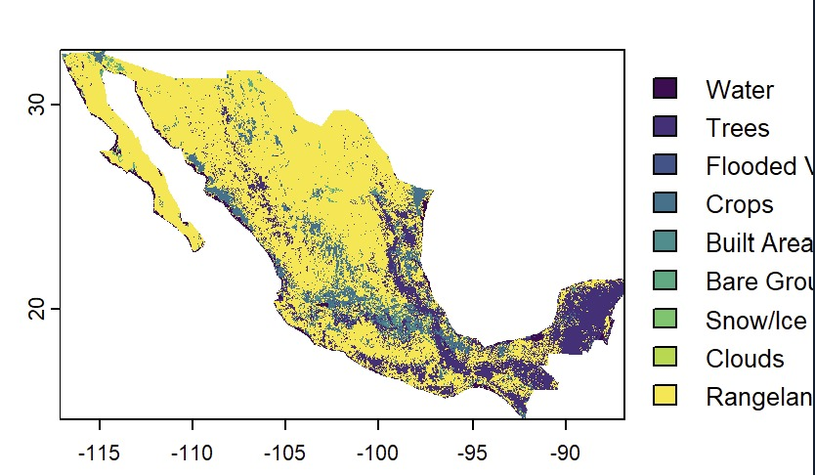
Figure 1. Land cover for Mexico, 2025. Classes: Water, Trees, Flooded vegetation, Crops, Built area, Bare ground, Snow/ice, Clouds, Rangeland.
The map shows the contrast the study needs. Rangeland covers most of the north and the central plateau, Trees dominate the Sierra Madre ranges and the Yucatán Peninsula, and Crops and Built area form scattered patches in between.

- Background points- Drawn with the same spatial bias as the records (target-group background)- {Sensitivit check- with distance-to-road weighting}
- Models- MaxEnt ^{7,8}, tuned with ENMeval 2.0 ⁹ rather than default settings. One tuned second algorithm (random forest, GAM or XGBoost) checks that results are not MaxEnt-specific¹⁰.
- Evaluation- Four designs, from most to least optimistic: random cross-validation, spatial block cross-validation, testing within each land-cover class, and leave-one-class-out cross-validation.
- Metrics- Continuous Boyce index, suited to presence-only data, and AUC.
- Fair comparison- AUC naturally varies with the size and climate range of the area tested. So each class is compared with ~1,000 random test areas of the same size and number of points; a class counts as poorly predicted only if it falls below that range.
- Statistics- Paired bootstrap confidence intervals for the Model 2 − Model 1 difference in each class; the spread among classes as our consistency measure; a mixed model across species (species as a random effect).

References
1. Thuiller, W., Araújo, M. B. & Lavorel, S. Do we need land-cover data to model species distributions in Europe? J. Biogeogr. 31, 353–361 (2004).
2. Pearson, R. G., Dawson, T. P. & Liu, C. Modelling species distributions in Britain: a hierarchical integration of climate and land-cover data. Ecography 27, 285–298 (2004).
3. Hijmans, R. J. Cross-validation of species distribution models: removing spatial sorting bias and calibration with a null model. Ecology 93, 679–688 (2012).
4. Roberts, D. R. et al. Cross-validation strategies for data with temporal, spatial, hierarchical, or phylogenetic structure. Ecography 40, 913–929 (2017).
5. Karra, K. et al. Global land use / land cover with Sentinel 2 and deep learning. in 4704–4707 (IEEE, Brussels, Belgium, 2021). doi:10.1109/IGARSS47720.2021.9553499.
6. Johnston, A. et al. Analytical guidelines to increase the value of community science data: An example using eBird data to estimate species distributions. Divers. Distrib. 27, 1265–1277 (2021).
7. Phillips, S. J., Anderson, R. P. & Schapire, R. E. Maximum entropy modeling of species geographic distributions. Ecol. Model. 190, 231–259 (2006).
8. Phillips, S. J., Anderson, R. P., Dudík, M., Schapire, R. E. & Blair, M. E. Opening the black box: an open-source release of Maxent. Ecography 40, 887–893 (2017).
9. Kass, J. M. et al. ENMeval 2.0: Redesigned for customizable and reproducible modeling of species’ niches and distributions. Methods Ecol. Evol. 12, 1602–1608 (2021).
10. Valavi, R., Guillera-Arroita, G., Lahoz-Monfort, J. J. & Elith, J. Predictive performance of presence-only species distribution models: a benchmark study with reproducible code. Ecol. Monogr. 92, e01486 (2022).

